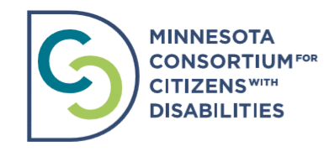

MNCCD 2021 Individual Membership Application Form
The Minnesota Consortium for Citizens with Disabilities (MNCCD) is a broad based coalition of advocates working to change public policy to create a more equitable society for people who have disabilities.

MNCCD does this work by building awareness, providing education and engaging the community. Minnesotans who have disabilities, their family members, and allies can be individual members of MNCCD if they share our mission, vision, and values.

People who already work with MNCCD through a member organization are not eligible for individual membership. Employees of an organization that would qualify for membership are generally not eligible for an individual membership.

Please send your completed membership application with your payment to Bridget Carter at bcarter@mnccd.org or 5304 36th Ave S. Minneapolis, MN 55417.

MNCCD Individual Membership Contact Information

Name:

Email:
Phone number:

What legislative district do you currently live in? To find your district information, follow the link: https://www.gis.leg.mn/iMaps/districts/

MNCCD is dependent on members contributing their time, capacity and talents. As a member, we need your participation to achieve our goals. Please check which committee you are interested in serving on or which area you have an interest in:
- Policy Committee
- Communications Committee

- Anti-Discrimination and Intersectionality Committee

- Tuesdays at the Capitol/ Grassroots Committee

Suggested individual membership dues for the year are $25. Please indicate the amount you are able to pay.

- $25

- $20

- $15

- $10

- $5

- I would like to apply for a financial scholarship to assist in paying membership dues.

To pay dues electronically, please pay via the MNCCD PayPal account. To pay membership dues please visit the MNCCD website and scroll down to the Donate button on the homepage.

If you are paying by check, please make checks payable to MNCCD. In the subject line please include: MNCCD Membership Dues. Please mail check to MNCCD: Attention Bridget Carter 5304 36th Ave S. Minneapolis, MN 55417.

Memberships will run for 12 months beginning January 1. As MNCCD is a 501-(c)-(4) nonprofit organization, membership dues and contributions are not tax-deductible.

If you have any questions or encounter any problems, please contact Bridget Carter.

