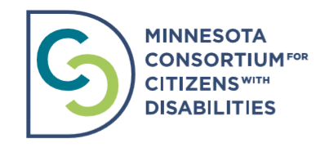
Minnesota Consortium for Citizens with Disabilities Board of Directors Application
Please complete the following and attach a resume that includes volunteer experience. Email your application, or request an accessible application to Bridget Carter at bcarter@mnccd.org.

Are you applying as a community representative or a member organization? If you are applying as a member organization, what is your organization? Click here to view MNCCD current member organizations.

Applicant Name & Job Title:
Phone:
Email:
Mailing Address:

Please answer the following questions. Create more space as needed.
1. Please tell us about skills and experience not on your resume that support board work such as Fundraising, Accounting, HR, Marketing, Communications, and Advocacy.

2. Tell us about your connection to disability and why you want to join our board at this time?

3. Elaborate on your experience with group process.

4. Of the following, please indicate which committee / committees would you like to serve on?
- Finance Committee
- Policy Committee
- Anti-Discrimination and Intersectionality Committee
- Communications Committee

5. Generally MNCCD member organizations support their employees in board participation. Have you discussed your application to our board with your employer and the time commitment (minimum 2-4 hrs. per month) that it requires?

6. Our Board meetings occur the last Thursday of every other month from 2:30 - 4:30p.m. Does this time work with your schedule? Please note that day and time might change for 2021.

