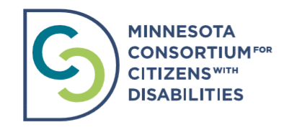

MNCCD 2022 Membership Application Form
The Minnesota Consortium for Citizens with Disabilities (MNCCD) is a broad based coalition
of advocacy and provider organizations working to change public policy to improve the lives of people with disabilities through building awareness, providing education and engaging the community.
Organizations eligible for membership are those that serve and/or advocate on behalf of Minnesotans with disabilities. Governmental agencies may be members of MNCCD only if their statutory mission includes advocacy on behalf of Minnesotans with disabilities.

MNCCD Membership Contact Information

The primary MNCCD contact within my organization will be:

Name: Title:

Email: Phone number:

Organization Name:

Organization Address:

Organization Website:

The secondary MNCCD contact within my organization will be:

Name: Title:

Email: Phone number:

Organization Name:

Organization Address:

Organization Website:

Preferred Organization Name for Promotional Materials:

MN Legislative Districts where your organization has a presence (provides services, works with individuals and families, etc.) To find your district information, follow the link: https://www.gis.leg.mn/iMaps/districts/

My organization’s primary service area, and/or most active policy advocacy issue area (check all that apply):

❑ Housing ❑ Employment ❑ Education ❑ Transportation ❑ Children ❑ PCA/Home Care ❑ Autism ❑ Self Direction/Quality Assurance ❑ Accessibility
❑ Diversity, Equity, and Inclusion ❑ Medicaid ❑ Healthcare

Does your organization have a dedicated department or staff member serving in a legislative relations and/or policy advocacy capacity? If yes, we would like to invite that individual (or individual of your choice) to participate on our Policy Committee:

Name: Title:

Email: Phone number:

Does your organization have a department or staff member serving in a grassroots capacity? If yes, we would like to invite that individual (or individual of your choice) to participate on our Grassroots Committee:

Name: Title:

Email: Phone number:

Does your organization have a department or staff member working in communications? If yes, we would like to invite that individual (or individual of your choice) to participate on our Communications Committee:

Name: Title:

Email: Phone number:

Does your organization have a department or staff member involved in diversity, equity, and inclusion? If yes, we would like to invite that individual (or individual of your choice) to participate on our Anti-Discrimination and Intersectionality Committee:

Name: Title:

Email: Phone number:

Dues Structure for 2022 Membership

ORGANIZATION ANNUAL BUDGET | DUES
Over $100,000,000 | $3,600
$50,000,000 – $100,000,000 | $3,450
$10,000,000 – $50,000,000 | $3,300
$1,000,000 – $10,000,000 | $3,200
$750,000 – $1,000,000 | $2,400
$ 500,000 – $ 750,000 | $1,650
$ 200,000 – $ 500,000 | $ 825
$100,000 – $200,000 | $ 375
Under $100,000 | $175

Designated voter from organization for full membership votes:

Operating Budget for the current fiscal year: $

2021 Membership Dues Amount Included $ __________________

Donation $ ________________________
Please consider adding to your dues amount a donation to support our work and help with MNCCD’s financial sustainability. Thank you!

To pay dues electronically, please pay via the MNCCD PayPal account. Please click here to pay membership dues.

If paying by check, please make checks payable to MNCCD. In the subject line please include: MNCCD Membership Dues. Please mail check to MNCCD: Attention Bridget Carter 5304 36th Ave S. Minneapolis, MN 55417

Memberships will run for 12 months beginning January 1, 2022. As MNCCD is a 501-(c)-(4) nonprofit organization, membership dues and contributions are not tax-deductible.

If you have any questions or encounter any problems, please contact Bridget Carter.
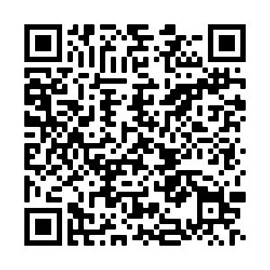

Please list additional members of your organization who would like to receive communications from MNCCD (name and email address):

Name: | Email:
Name: | Email:
Name: | Email:
Name: | Email:
Name: | Email:

